Project 10 – Masterpiece

Developed and Documented by:

Toqa Jamal Swedat

**May 2022**



My project idea will be used to buy different bags

So this web application is important for bag-obsessed people and for people who just need a bag as it saves time and effort for customers. Customers can buy bags

Through this system, and those who do not have enough time to go to the shops and markets personally and look at them, all you have to do is select the type of bag through the options available through the site, view this system, see all the features and details of the bag and choose among them.

My web application has the ability to add rating and comments by customers.

Each customer must create their account to be able to purchase, write reviews and associate them with the type of payment.

Any guest can access this app for review without creating a file

the account.

**Database Design**

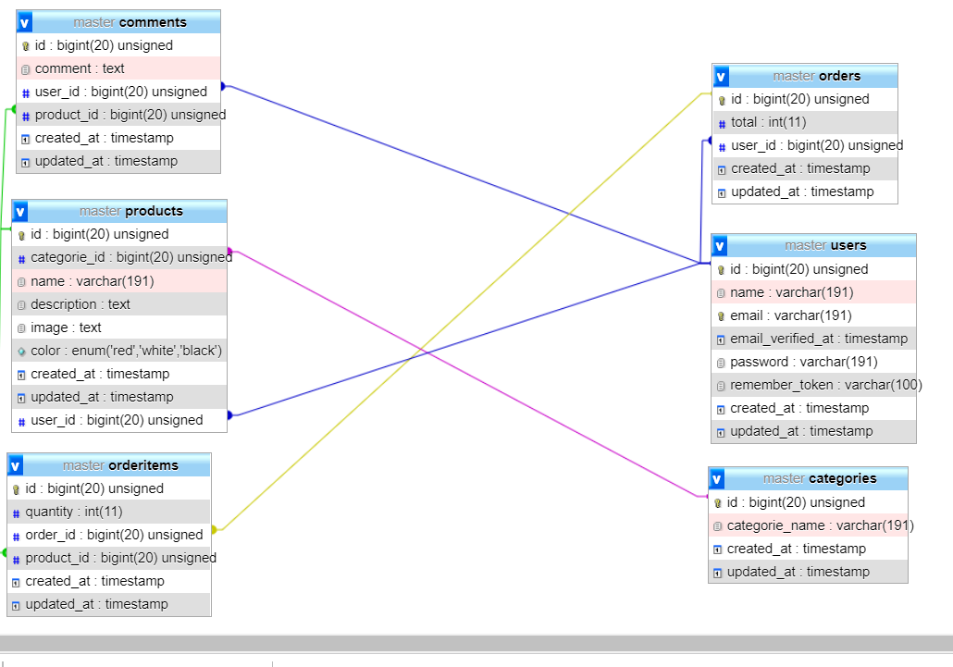

Use case

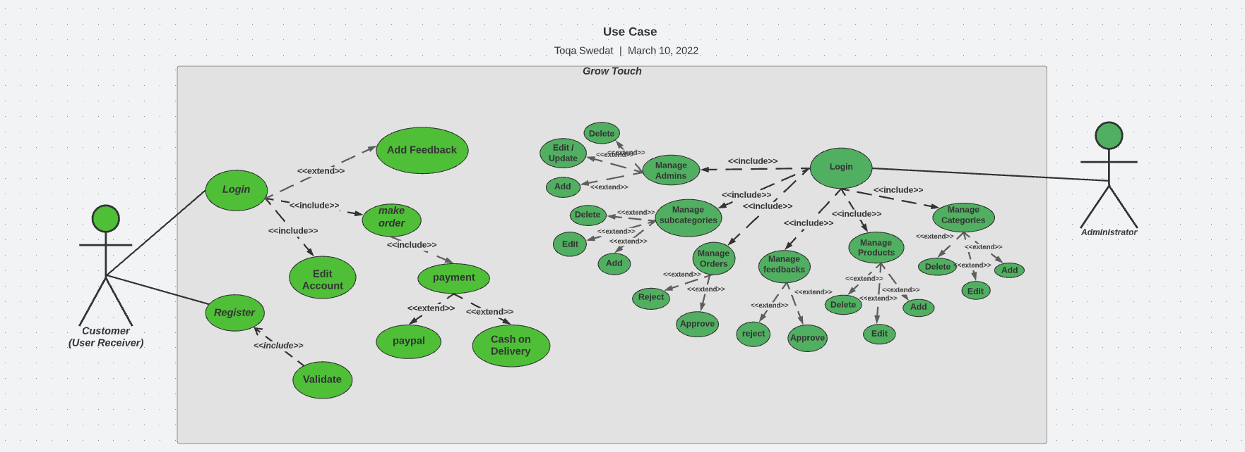

**future work**

Belief in continuous development and the need to preserve the value of it

Increase the system, here is a list of improvements and features to be made

Added to the site:

1. Expand product categories beyond bags

2. Add region/country classification

3. Implement live chat for users to interact directly about products